COSC 342 Assignment 1 – Image Mosaicing

Report for Zac Seales, ID #6687905

Introduction
In Image Mosaicing, there are 2 common feature matching methods;
- Brute Force, which checks every single possible match to determine the best match possible.
- Flann-Based (k-d tree), which splits the image space into regions and only searches for matches within each region.
This report aims to test both methods to determine the optimal matching efficiency, dependent on a variety circumstances. Feature matching efficiency will be determined by; time taken, number of features, number of inliers, and mosaicing accuracy (tested with the naked eye).
Once matching is complete, a homography will be created that maps one image to the other. This homography is a linear map between the 2 images, and is determined by; the inlier matches, and a RANSAC threshold value.
RANSAC is the method OpenCV will use to calculate the homography matrix.
The RANSAC threshold will determine the number of inlying matches.
As a secondary experiment, the RANSAC threshold value will be altered to test what difference occurs and whether there is an optimal threshold value for each scene.
All tests will use the same set of image pairs and the same testing code.
Each test will take 2 images. The image with the least number of features will have the second image pasted over the top. The position of the second image will depend on the homography.

Experiment 1: Feature Matching

Hypothesis/Question:
Flann-Based matching involves building a k-d tree that represents the regions of the split image. Building the tree creates some overhead but then using the tree for approximate matching will be very fast.
A common theory is, Flann-Based matching will be faster than Brute Force matching, for a large number of features. But Brute Force is supposedly faster for images with fewer features.
This experiment aims to determine, under what circumstances is Flann-Based matching faster than brute force matching?

Experimental Design:
Feature matching will be tested using the OpenCV ‘SIFT’ functions; BruteForce, and FlannBased. All tests will use the default RANSAC threshold value “3.0”.
I’ve taken a variety of photo-pairs that cover a range of scenarios, including; rotating camera, translating camera, repeated patterns, complex images, simple images (with fewer features), and planar scenes.
Each image pair will be run through the program 10 times to ensure reliability and consistency. The program will output; the total number of features detected, the time taken for features to be matched, the total number of inlying matches, and the final mosaic image. These values should give a good idea of the optimum circumstances for each method.

Results: (The background image is Img#a, Foreground is Img#b)

Img1a = 3585 features Img1b = 4806 features
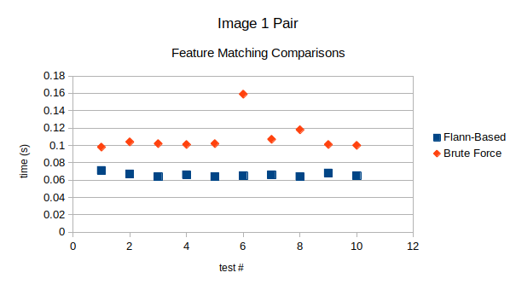
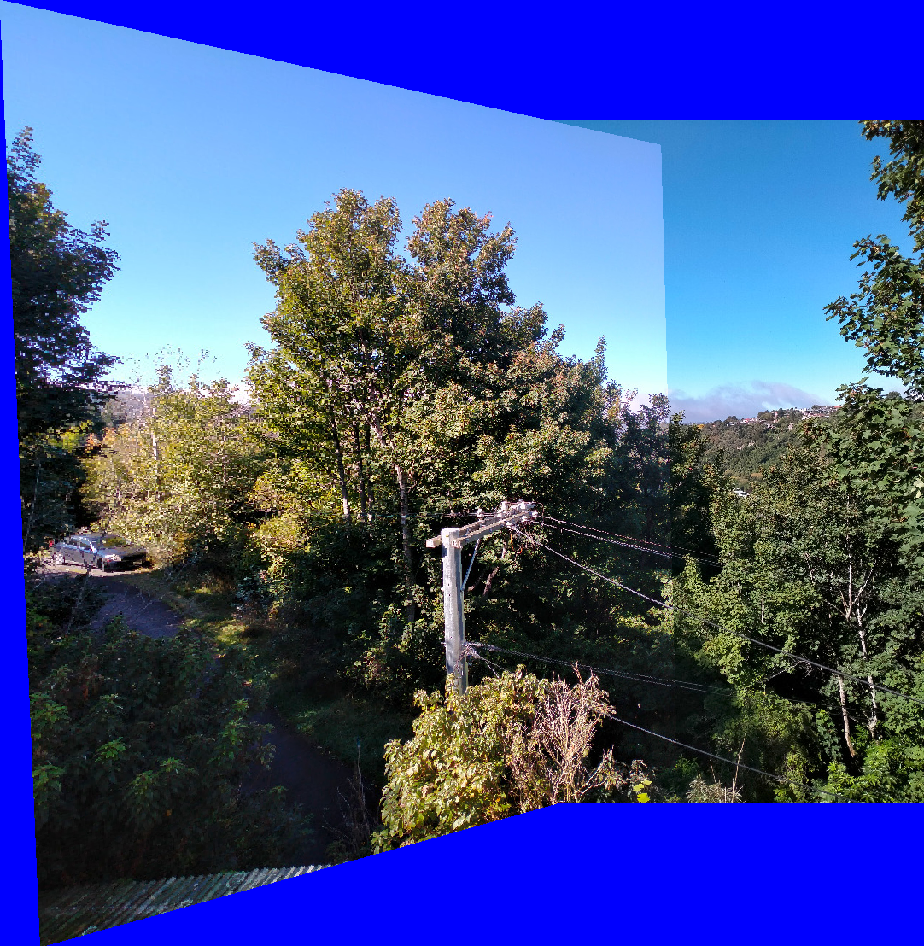
The results of image pair 1 coincide with the theory. Brute Force is clearly slower, though the difference is miniscule. Brute Force filtered out 504 inliers from the 3585 possible matches, whereas Flann-Based found 528. This scenario seems relatively consistent throughout all tests, which I found surprising.
Logically, Brute Force should find more matches since it’s considering more possibilities.
Both tests created the same mosaic, which also occurs in every test.

Img2a = 4409 features Img2b = 5942 features
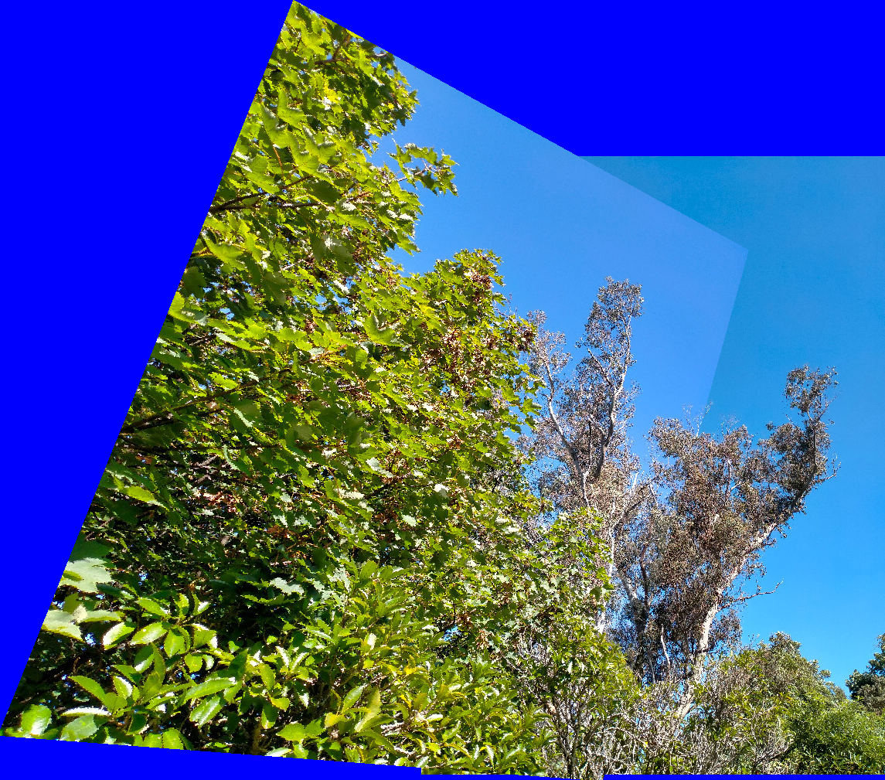
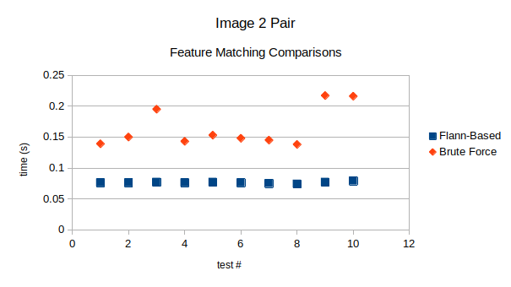

Again, an expected outcome. Flann Based resulted in 170 inliers, whereas Brute Force had 155 inliers. A lot of matches have been filtered from the original 4409. Another trend occuring is Flann-Based matching seems far more consistent in terms of time taken. Brute Force creates more deviation, possibly because that extra time is more likely to result in a thread collision, though I’m just hypothesizing.

Img3a = 5017 features Img3b = 7588 features
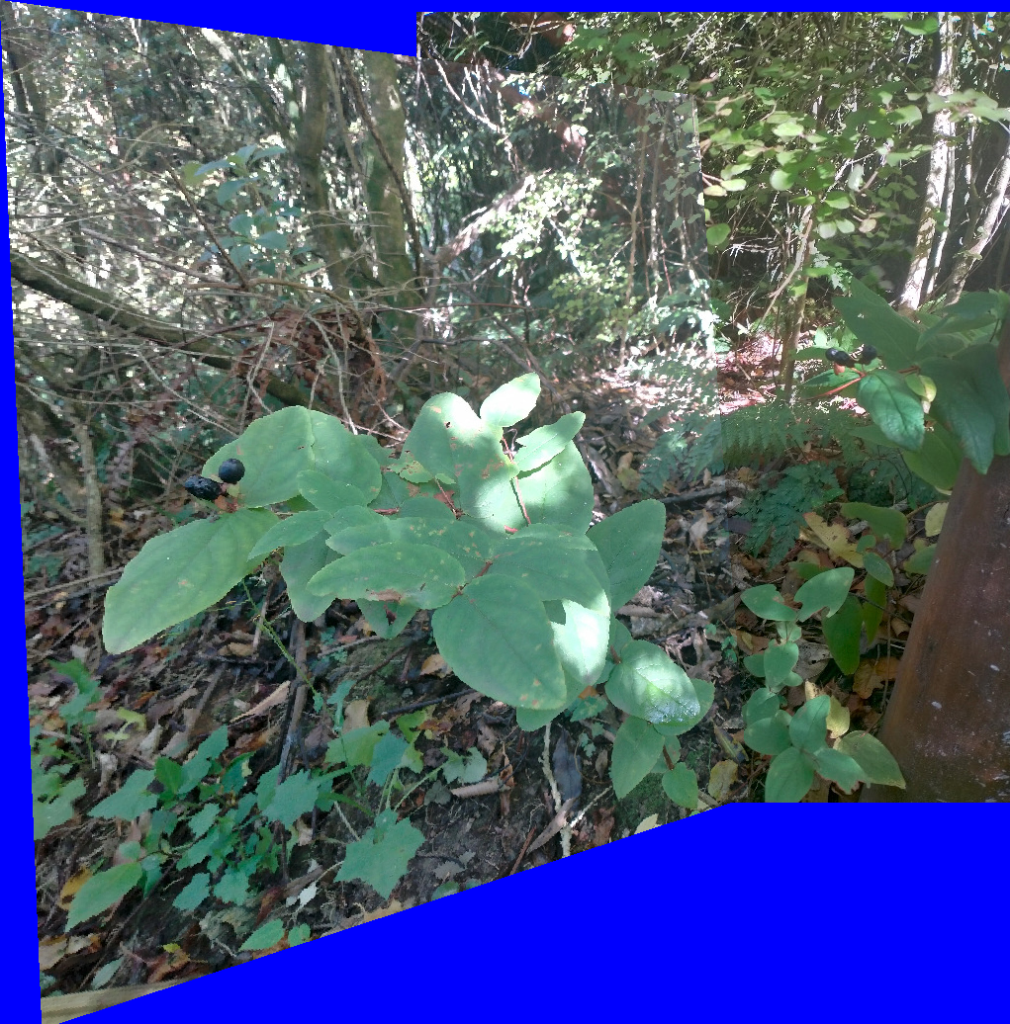
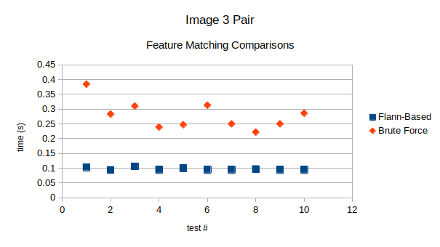
Here, Flann-Based matching found 739 inliers, whereas Brute Force found 712.
This scene is similar to the previous image pairs, except more inlying matches occur which results in more time taken.
This is another somewhat surprising discovery. Each method results in 5017 matches before filtering. I assumed that removing more matches would take longer. Perhaps it does but the warping has more overhead because there are more matches to combine. Again, just hypothesizing possibilites as I receive relatively expected results. Brute Force = slower.

Img4a = 2938 features Img4b = 3137 features
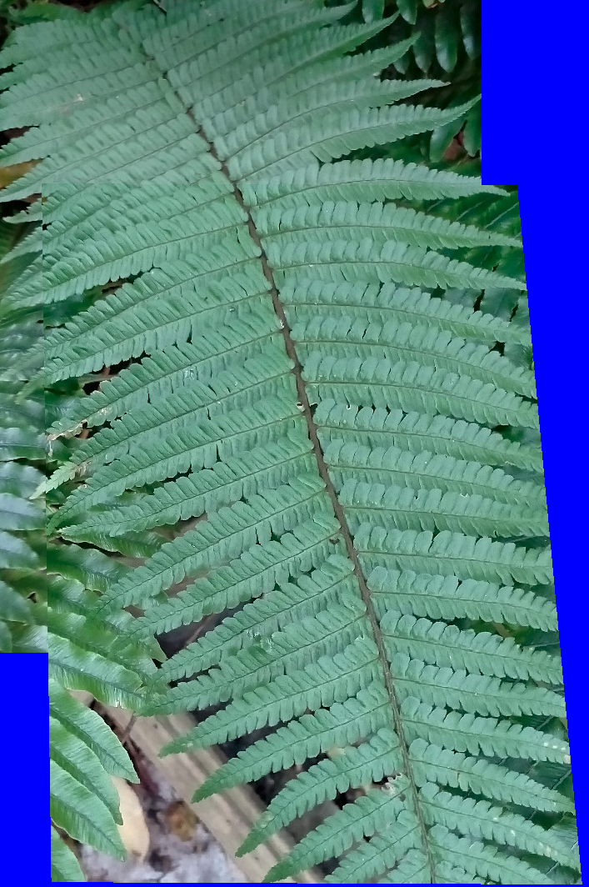

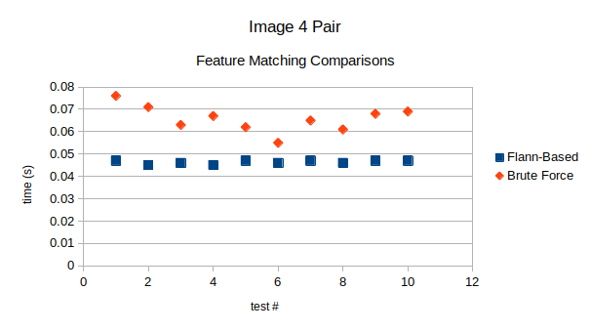
Flann-Based had 547 inliers,
Brute Force had 513.
Less features has resulted in a much smaller difference but how many features will make Brute Force Faster than Flann-Based?
Img5a = 604 features Img5b = 1121 features
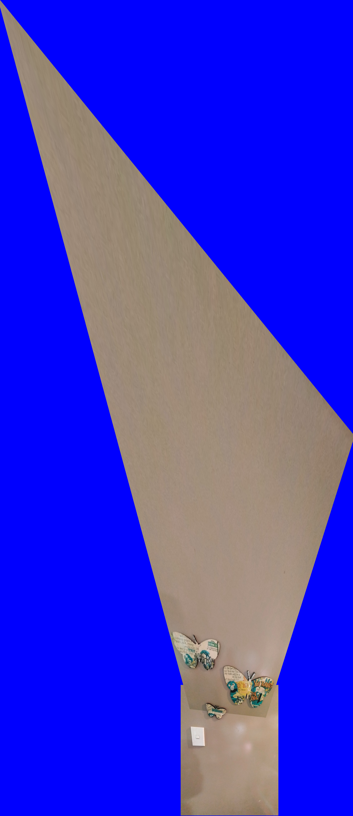

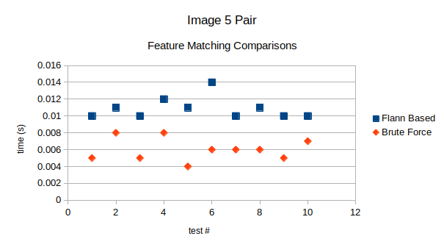
Fifth time’s the charm, With 183 inliers of a possible 604 matches, Brute Force has finally become faster than Flann-Based matching. Flann-Based found 184 inliers so once again, the number of inlying matches is meaningless.
Both methods are just as accurate as one another.
What’s interesting is that even though previous tests created fewer inliers, the fewer total features is what made Brute Force matching faster.
The overhead of the k-d tree building is now taking longer than the extra computation provided by Brute Force.

Img6a = 2669 features Img6b = 2776 features
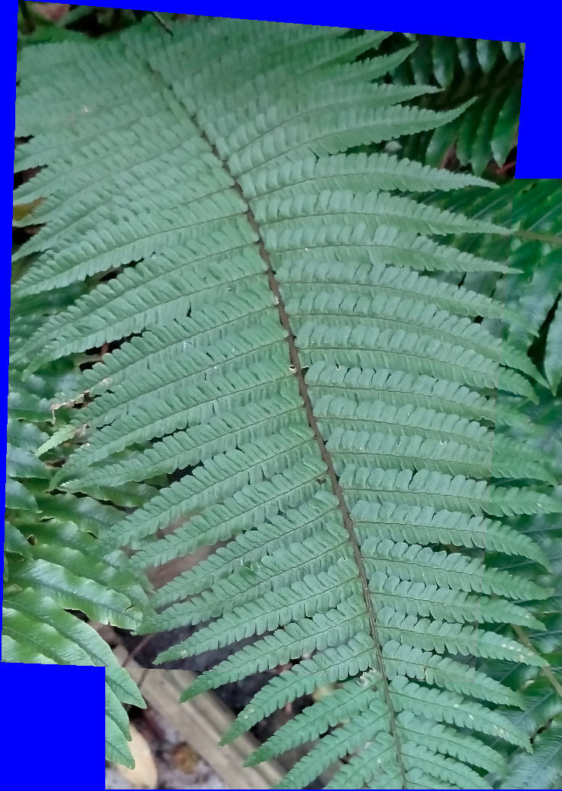

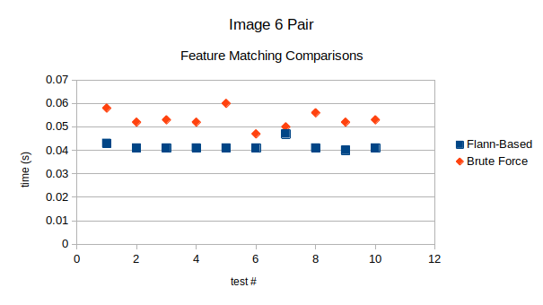
This image pair is a lot like Image Pair 4. I included it just to highlight that the smaller number of total matches (2669 compared to 2938 from Image4) has made Brute Force noticably faster, whereas Flann-Based hardly changed at all. It also resulted in more inliers which should make it take longer (based on the previous tests). It seems as though fewer total features results in faster matching even if there are more total inlying matches.
This image mosaic seems far more accurate than Image Pair 4 as well. Most likely due to my photography but the extra inliers may be part of the reason.
Img7a = 334 features Img7b = 363 features
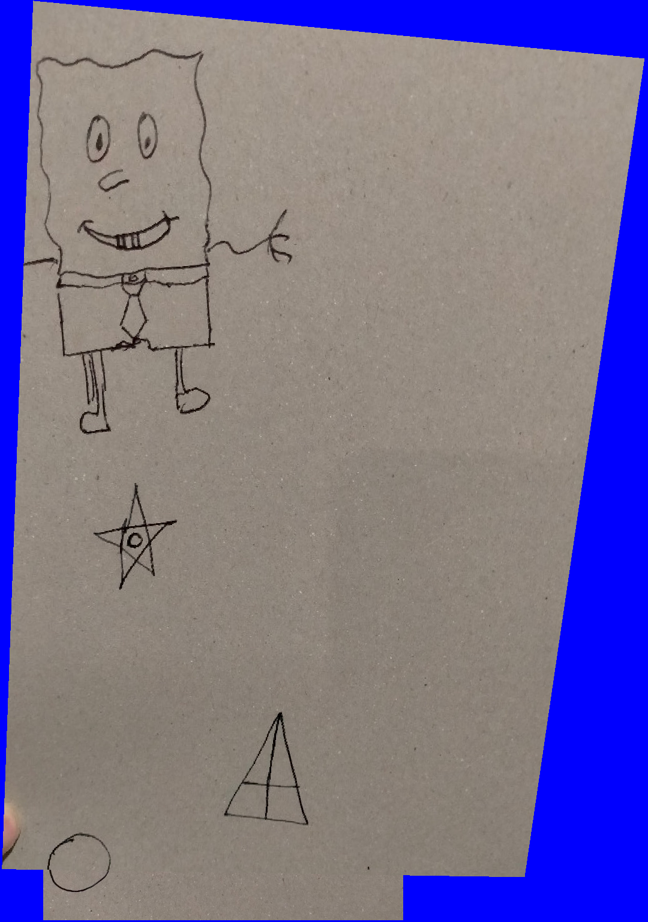

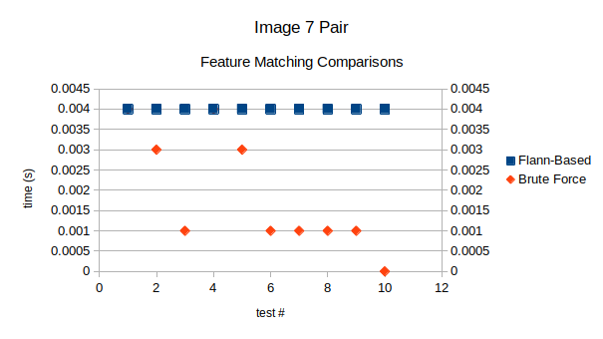

This pair of images highlights the need for a more accurate timer.
Firstly, Flann-Based matching took 0.004s every time. Although possible, this is very unlikely and I believe having the timer round to 3dp has created this scenario. Even so, Flann-Based is clearly more consistent in terms of time taken.
Secondly, Brute Force apparently took 0 seconds. This proves the need for a more accurate timer because, obviously brute force operations are always going to take time (unless there are zero inliers).
Apart from the timer being inaccurate, this image pair coincides with previous test results. Fewer features results in Brute Force being faster than Flann-Based matching.

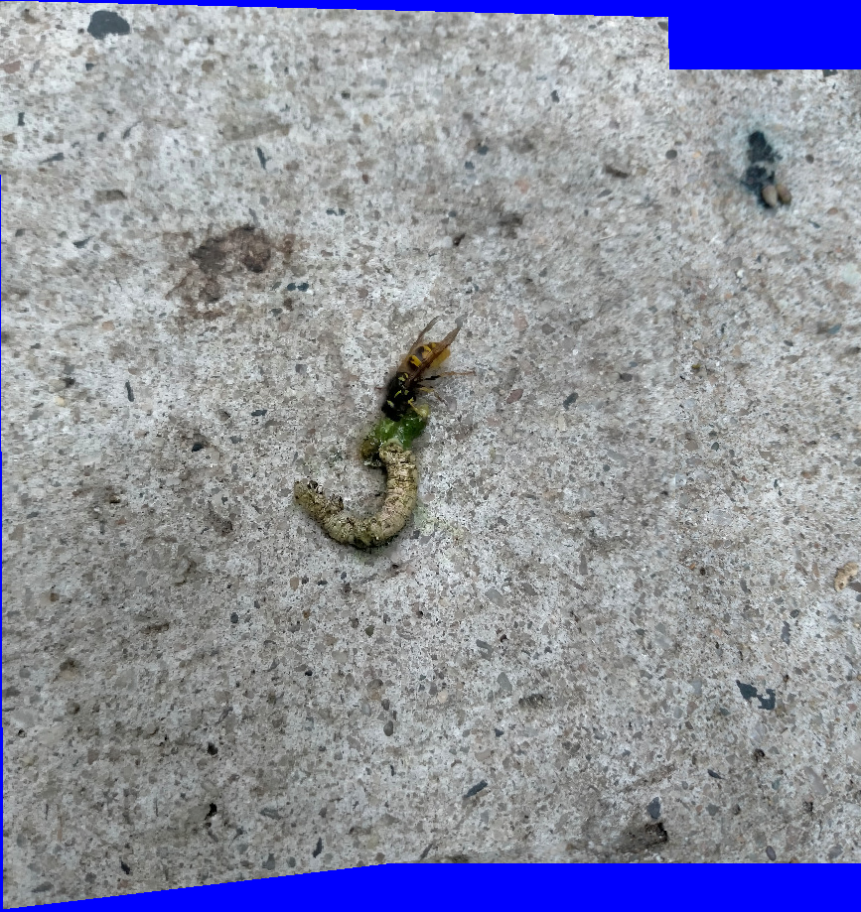
Img8a = 8690 features Img8b = 8932 features
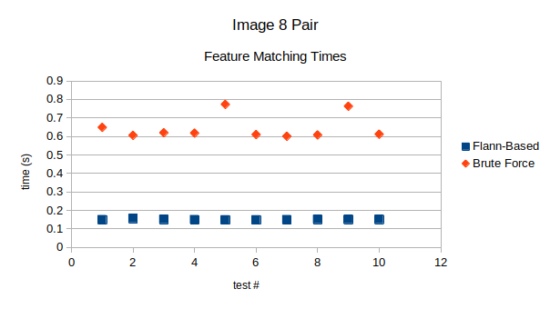
FlannBased = 2176 inliers, Brute Force = 2291 inliers
Again this image pair shows no new results.
A lot of features means Flann-Based is the definitely the faster approach.
I just wanted to show off the picture I took of a wasp eating a live caterpillar.
I’ll admit, I’m surprised at how accurately both methods matched up the dirty concrete scene.

Img9a = 10633 features Img9b = 12834 features
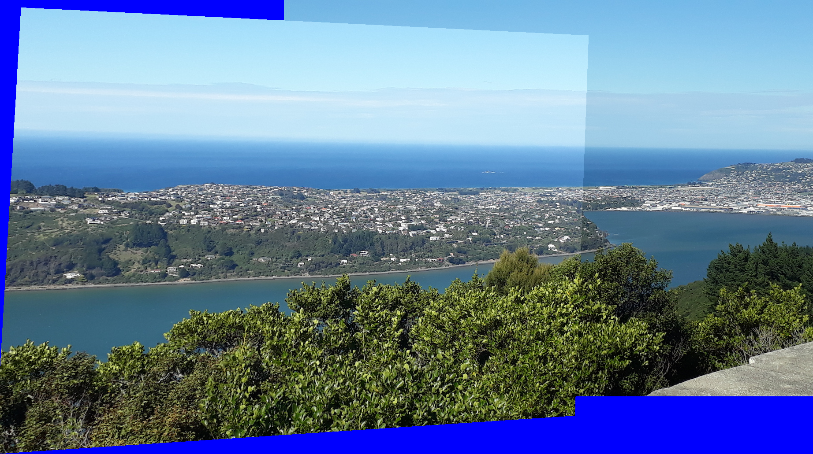

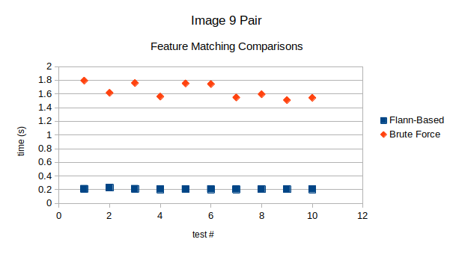
These last 2 image pairs (8 and 9) have the most total features, they clearly show that Flann-Based matching method is significantly faster when total features increases.
Image Pair 9 had approximately 2000 more total matches and brute force took twice as long (an extra 0.5s).
This is by far the biggest difference in the 2 matching method times, which suggests Brute Force becomes obsolete very quickly as total features increase.

Discussion/Conclusions:
I just proved the theory is likely to be true. If an image pair has more total features to match, then the k-d Flann-Based approach is definitely the optimal solution.
The difference in mosaic accuracy was non-existent (To the naked eye, both matching methods created identical mosaics).
Brute Force is only faster for very simple images with very few features, and even then the time difference is hardly worth noting.
Depending on the application and images, Brute Force may be best for your situation, but I would recommend k-d as the best solution.
The overhead of the Flann-Based matching was extremely consistent, and only for the very simplest of images did it result in a slower time.
The overhead of each matching method is largely caused by the total number of features. The same number of features with more inliers had an insignificant difference.
This was a very simple experiment so, of course, no definitive results can be obtained. The timer only rounded to 3dp which caused obvious issues with Image Pair 7. I only tested a small variety of images. I’ve tried to take varying photos but, in terms of features and inliers, they are all quite similar. A larger set of test images would certainly provide a more accurate result.
However, based on the initial theory and this simple testing, it seems the conclusion is clear...
More total features means Flann-Based matching is faster than Brute Force.

Experiment 2: RANSAC for Homography Estimation

Hypothesis/Question:
How does the choice of RANSAC threshold affect the accuracy of the homography?
Is there an ideal threshold value dependent on total features?

Experimental Design:
This experiment will use many of the same components used from the feature matching experiment. The same code will be used to test the same set of images.
However, There are 2 major differences;

- The program will iterate the homography building 20 times, in order to quickly determine the number of inliers for each threshold (for thresholds 1 - 20), as well as the time taken to compute the homography.
- And, all tests will use brute force matching. Brute Force should provide the most accurate end result as it checks all possible matching possibilities. Time is less important for this experiment so there is no need to use the approximate Flann-Based approach.

All output variables will be the same, however this time I’ll be focusing more on inliers, the final mosaic, and the homography matrix.
By recording the number of inliers for each threshold and checking the accuracy of the mosaic, I hope to get a good idea of the optimal threshold value dependent on total features.

Results:
This graph (below) shows the number of inliers for each image pair over a range of RANSAC thresholds (1 – 20).
It shows a clear logarithmic increase in inliers as RANSAC threshold increases (with a few exceptions).
These results were relatively expected. As RANSAC threshold increases, the distance of matches that the algorithm will consider, gets larger. Meaning more match points will be considered further away from the ideal “homography of best fit”. Increasing the RANSAC threshold too far will make outliers have a large effect on the final homography.
One interesting thing to note is Image Pair 1 (504 inliers) increases slightly faster than Image Pair 4 (513 inliers). This seems to be the only exception and may be due to the fact that Image Pair 1 has more total features (approx. 1000 more).
As for the small ‘spike’ exceptions. I’m not sure what to make of them. I’d presume that either; they are due to my non-perfect rotation on non-planar scenes, or;
the change in homography has changed the number of inlying points within the threshold distance.
I did notice that the homography values always changed as threshold changed, usually an extremely slight change.
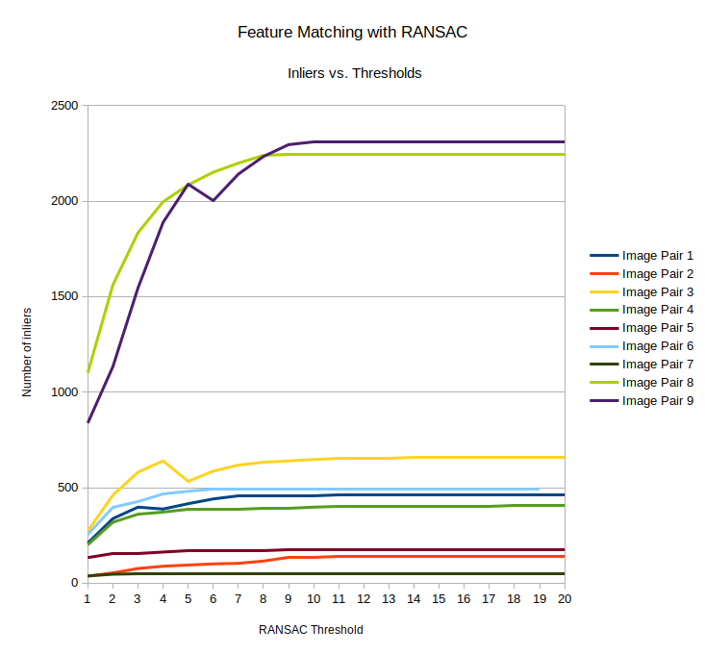
Total Inliers before RANSAC Calculation
1 = 504 6 = 594
2 = 155 7 = 97
3 = 712 8 = 2291
4 = 513 9 = 2347
5 = 183

These results are interesting but I haven’t determined any results regarding mosaic accuracy. All these mosaics could be considered accurate.
I haven’t included images because only the slightest changes occurred and I doubt you’d be able to see the 1 pixel differences (if that).
I found that for each image pair, a range of accurate thresholds was available. I’ve made a small chart of my findings.
For this chart, Accurate Thresholds and Max Thresholds are based on my personal opinion, judged by my eyes.
This table has no scientific value.
Image Pair | A Features | B Features |  | Accurate  Thresholds | Max Threshold
1 | 3,585 | 4,806 |  | 1 - 150 | 240
2 | 4,409 | 5,942 |  | 1 - 200 | 240
3 | 5,017 | 7,588 |  | 1 - 350 | 400
4 | 2,938 | 3,137 |  | 1 – 50 | 80
5 | 604 | 1,121 |  | 1 - 80 | 100
6 | 2,669 | 2,776 |  | 1-170 | 200
7 | 334 | 363 |  | 1 - 87 | 87
8 | 8,690 | 8,932 |  | 1- 1000 | 1100
9 | 10,633 | 12,834 |  | 1 - 500 | 550

It seems there could be a correlation between total features and range of accurate thresholds, but this is definitely not definitive proof.
Firstly the small sample set is enough to discount this test, but on top of that, several image pairs had exceptions.
Pair 8 has by far the largest range which may be due to the fact that the monotonous concrete background always look accurately matched. I only capped the max threshold at 1100 because the wasp was becoming a little stretched. But It still seemed well matched.
For all others, there were obvious maximums. The seamlines were made obvious by small errors and often one corner would scale very large, creating pixelation noise.
The only other major exception was Pair 4. Which has a very small range of accuracy. This is the fern image pair which is almost identical to pair 6. It has slightly fewer inliers but not enough to constitute the drastic decrease in accuracy. I suppose it would be dependent on how far the features are from the homography of best fit. So Image Pair 4 would have most inliers already close to the homography, which coincides with my previous test. Image 4 inliers decreased slower than image 1 - as threshold increased - despite having more total inliers.
This result could be caused by the repeating pattern of the fern but doesn’t seem to have the same impact on image 6. More testing would need to be done.
The final interesting observation I made was with Image Pair 7. There was an exact threshold value which suddenly distorted the entire image (as shown below). For all other images - as threshold increased – the inaccuracies took the form of misalignment or heavy scaling, but for image pair 7...
I don’t know what to make of this result. The only other strange observation here is the number of inliers jumped from 57 to 59 (a large jump considering the logarithmic graphs). Which means 2 outliers caused this crazy distortion where it looks like all features of 1 image are trying to be matched to a single feature in the other.
IMAGE PAIR 7
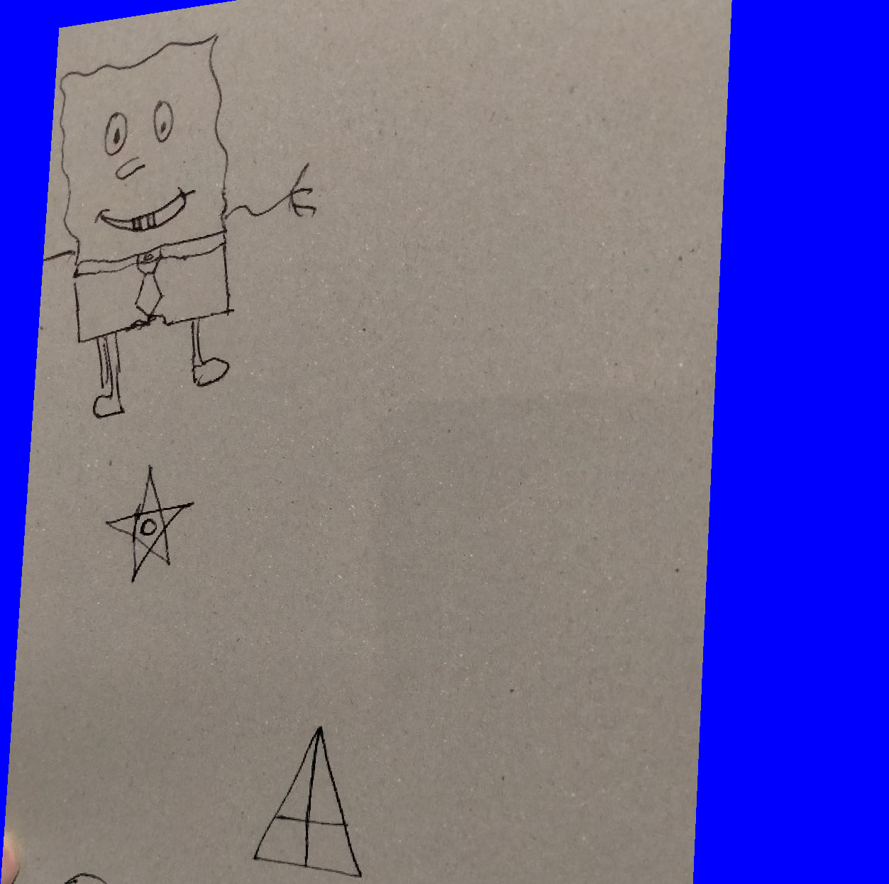
Threshold 87 Threshold 88

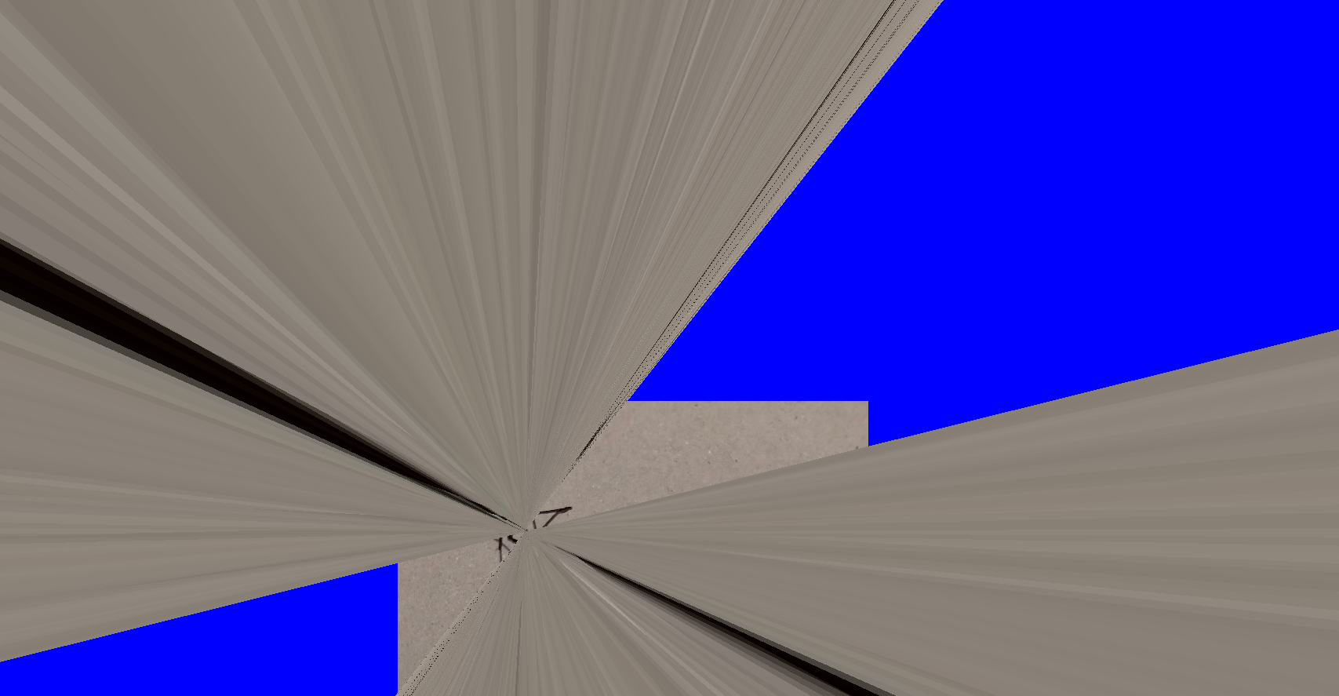

Discussion/Conclusions:
I wasn’t expecting threshold values to make such a drastic difference to time, but I’m also glad I chose not to test it. For all image pairs, the homography was computed in 0 seconds by threshold 100 (approximately). And by threshold 10, the majority of times were 0.001.
It’s very clear that the higher the threshold value is, the faster the homography is computed, but accurate testing is impossible with a timer that only rounds to 3dp.
The number of inliers considered while making the homography of best fit is decided by the distance defined by the RANSAC threshold value. Generally a smaller threshold is going to create a more accurate mosaic but there are exceptions, most likely caused by certain image scenes.
I can’t obtain any other clear conclusions from the results I’ve obtained.
It seems as though lower total features results in a smaller accuracy range, but then there’s a few exceptions. The small sample size and the few exceptions mean there is no definitive proof of my hypothesis.

Final Remarks
Image Mosaicing has many possibilities in terms of; where the images are placed and how to determine where to place the image. How you choose your mosaicing methods will largely depend on the current application.

Brute Force matching is faster than approximate matching when the total number of features is very small.
Approximate (Flann-Based) matching is significantly faster for complex images, and the overhead time is always more consistent than Brute Force.

RANSAC Threshold is generally more accurate for lower values. Although, higher threshold values will compute the homography much quicker.

These were the clearest observations made throughout my simple tests.

There’s still many uncertainties that could be clarified with further testing.
I’d like to test my theory of whether or not total features affect accurate threshold range. And if so, what is causing the exceptions in my testing. The main problem is defining what an accurate mosaic entails. In this report it is judged by my eye and my definition of accuracy (which is not a valid SI unit in the scientific community). If I were to continue testing I’d want to research seamlines and exact pixel differences to try and clearly define the most accurate mosaic. A few other ideal changes would be; a more accurate timer, and a larger sample size. More pictures would allow other variables to be tested/considered, such as; the image scene (outdoors, forest, concrete), approximate image depth, image lighting, gradients/contrast.

All of these factors, and more, may alter the results of testing.

Zac Seales 6687905

